Hugo Shebbeare

Installation Procedure for New SQL Server 2008 R2 Instances on Windows 2008 R2
- Log on to machine with Remote Desktop and load installation media (Z drive on this VM, for example) – and click on Setup from the root.

Prerequisite is that you ensure Dot Net Framework core role is enabled, thus click OK for the update.
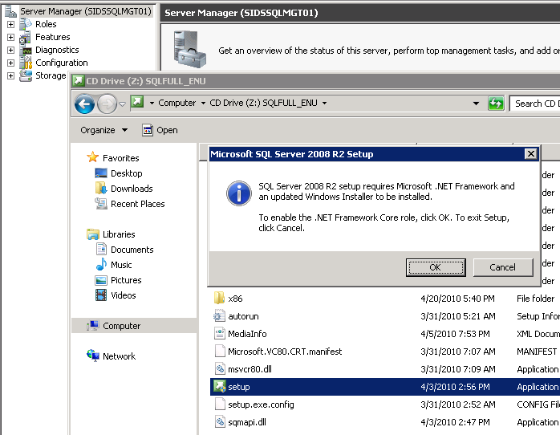

- Click on Installation, then 'New SQL Server stand-alone installation…' (top)
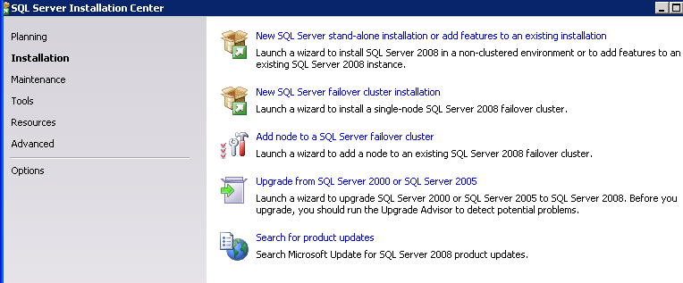
If you are adding features to an existing one, click on the top link also.

- Let the setup rules check run:
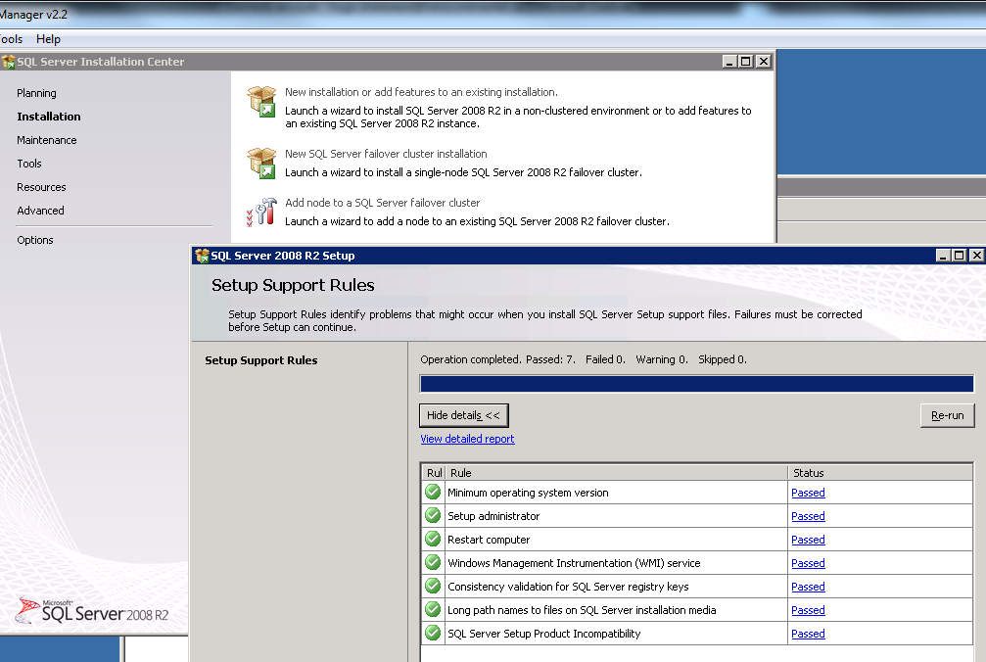
Enter key or make sure there is key automatically taken from the ISO, or enter it manually.

- Accept the terms and conditions
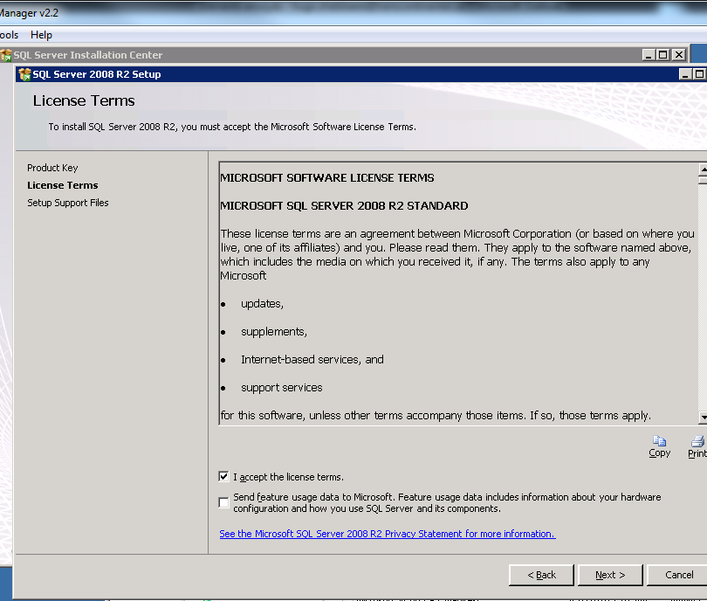
- Click install
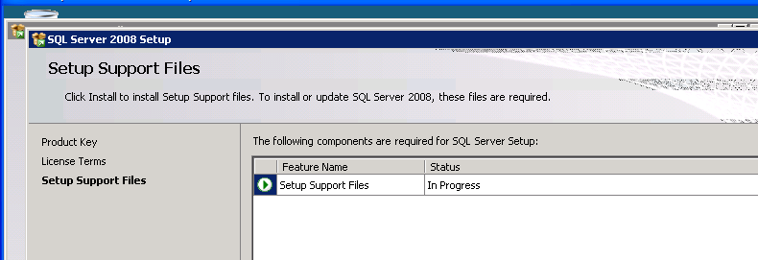
- Make sure the pre-install checklist provides a Passed Status for each rule.
then click Next.
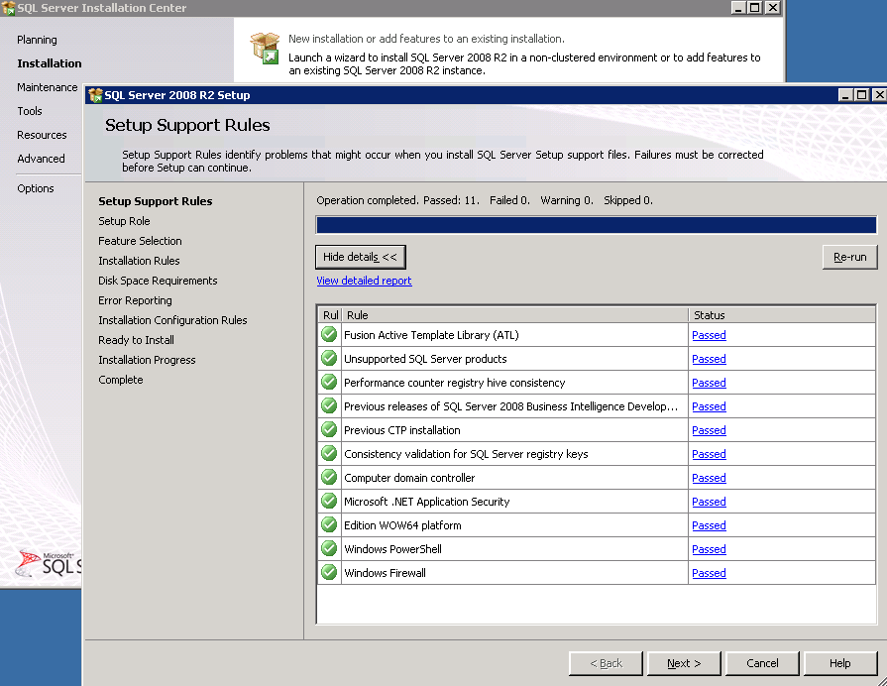

- DB Server - Do not choose default, continue with Feature Selection for a Server install (more components than for workstation)
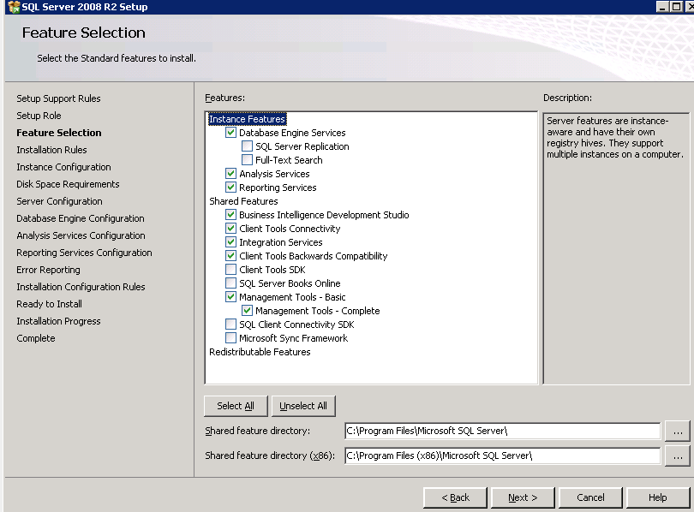
In the case of the server above, there is a 40GB C drive, so the Shared Features Directories are placed on C drive. If there is a Apps Drive available (e.g. D) and C is small, choose the drive allocated for program files (because the system databases will be placed on this drive by default).
Note that if this is for a client installation, do not select ANY of the INSTANCE Features, just Shared Features should be selected, as follows (or choose more if you need, I recommend this as a minimum):
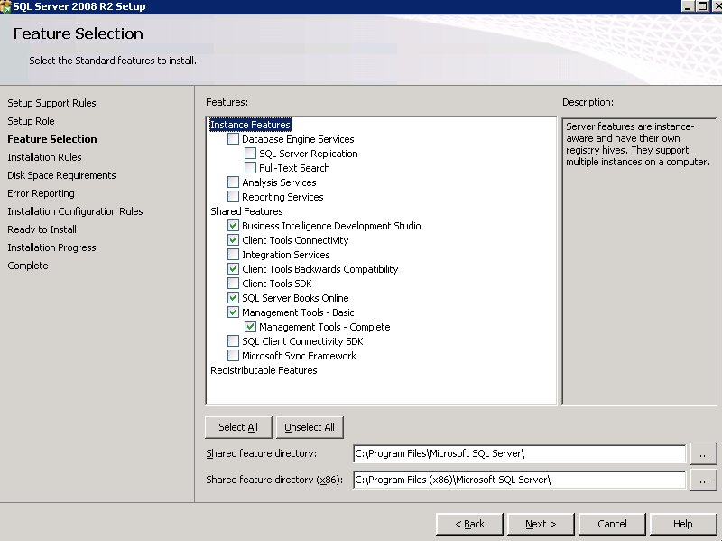
- A new installation step added in 2008 R2 is this Installation Rule Confirmation:
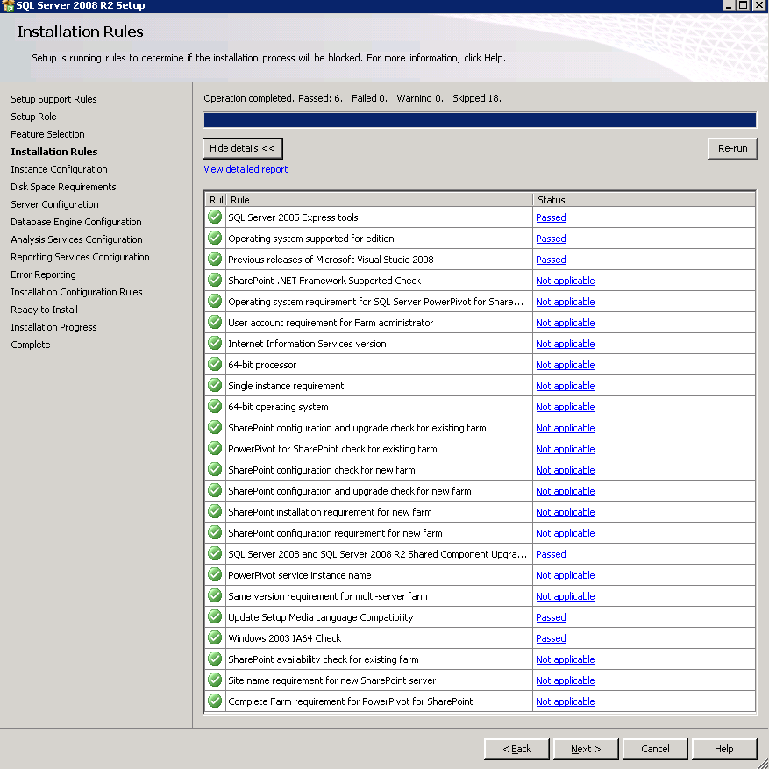
- Chose Default instance (so that the machine is accessed directly at ServerName), or specify instance name (as in SererName\InstanceName) if it is required and several are on the same machine.
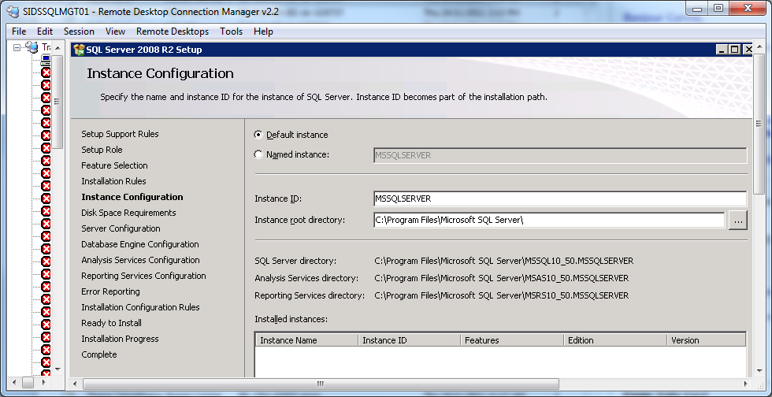
Click Next (make sure everything is run on C drive in our case, or D if there is a dedicated Application drive)
Here is where, as mentioned above, if you need to create a specific instance\alias name, you would specify it by selecting named instance.
- Validate Disk Space Requirements and click next
eg 1 – where there is an application drive designated (smaller C on purpose)
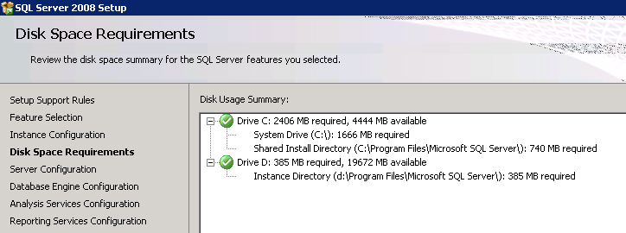
g 2 where the C drive is significant in size to hold system databases also.
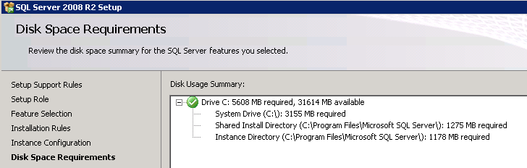
- Server Configuration
Click on Use the Same account for all SQL Server services
eg1 for a development server just use the system account.
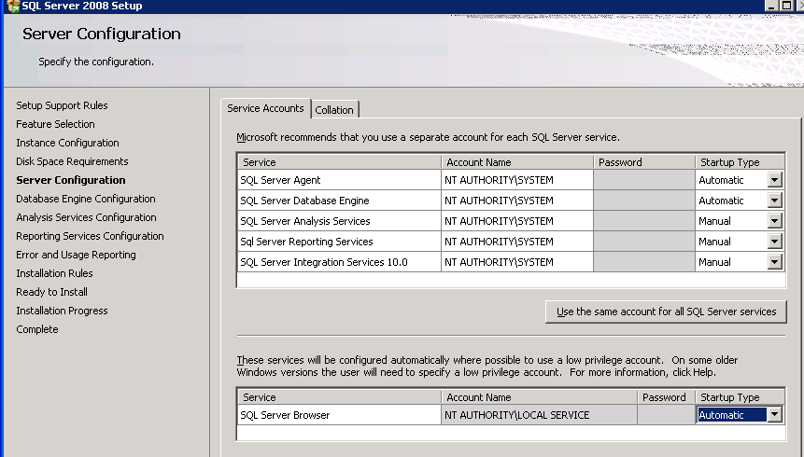
For a production SQL Server chose Domain\SQLDomainServiceAccount
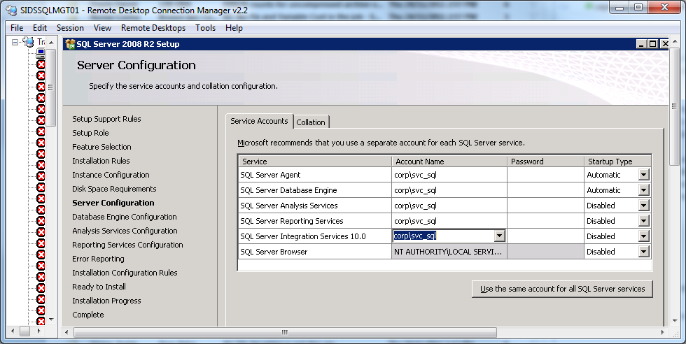
If you have the password handy (NEED SYSADMIN help, DBAs do not know this password for SODuties reasons), click User the same account for all SQL Server services:
Add Domain\SQLDomainServiceAccount - startup is auto for the Engine and Agent, leave the rest disabled until needed, if they are at all.
Leave the Collation tab as is, SQL_Latin1_General_CP1_CI_AS is the default and is Accent Sensitive and Case Insensitive.
- Select Windows Authentication mode, and add the Domain\DBA group (or the specific members as per your specific organisation).
If you are installing the Client, this step of the installation process will not exist, move forward to the matching confirmation screen in this document.
In the case of a local development installation, add the specific domain user, so that they may operate their own instance. I usually switch to Mixed Mode AFTER the installation, and add alternative accounts for the specific DBA group members with SA privileges.
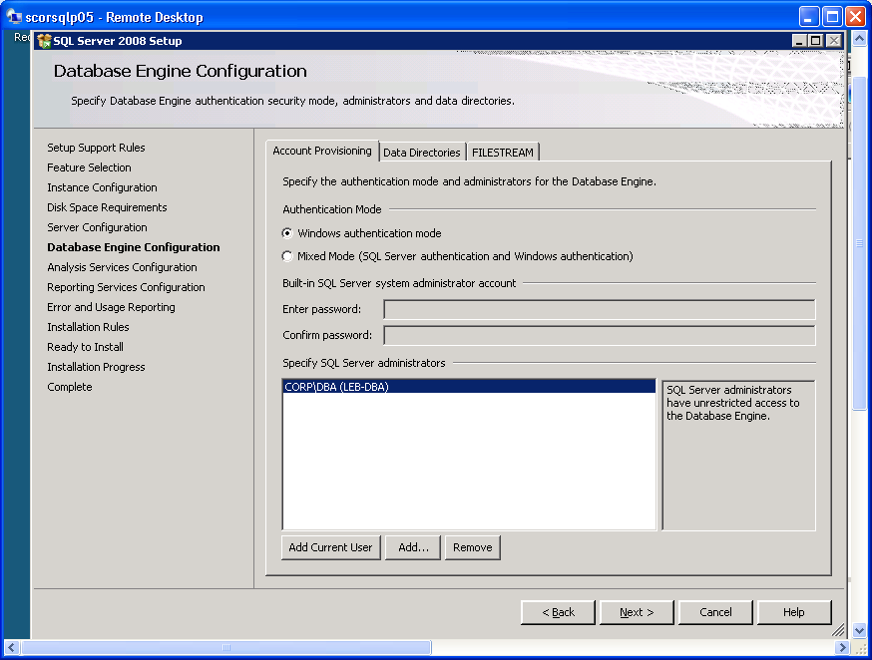
13) Root directories for Data, System DBs., User DBs., Temp and Backups.
Eg 1 – dedicated D drive for SQL Server and no space on C drive, nor a dedicated Temp Drive. For this installation I did not have other disks, but I prefer to have a drive for Temp dedicated, as well as one for Logs. Make sure to choose those drives here!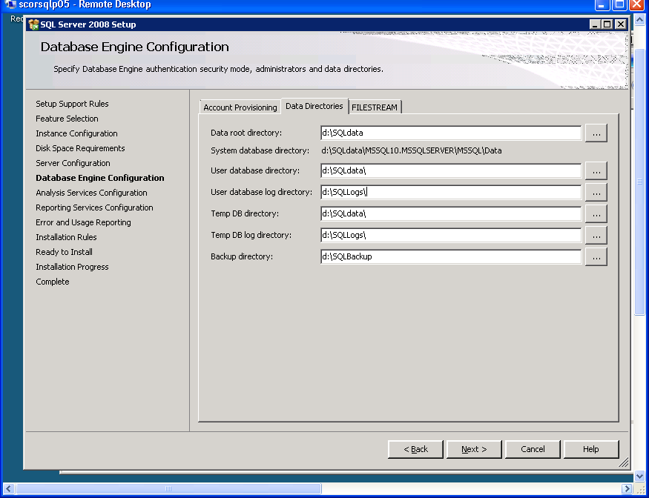
eg 2 if your C drive is large enough, you can leave the Temp DB there (and ideally, if performance becomes an issue, ask the VM admins to dedicate a 10-15GB drive just for the temp database on a separate dedicated disk).
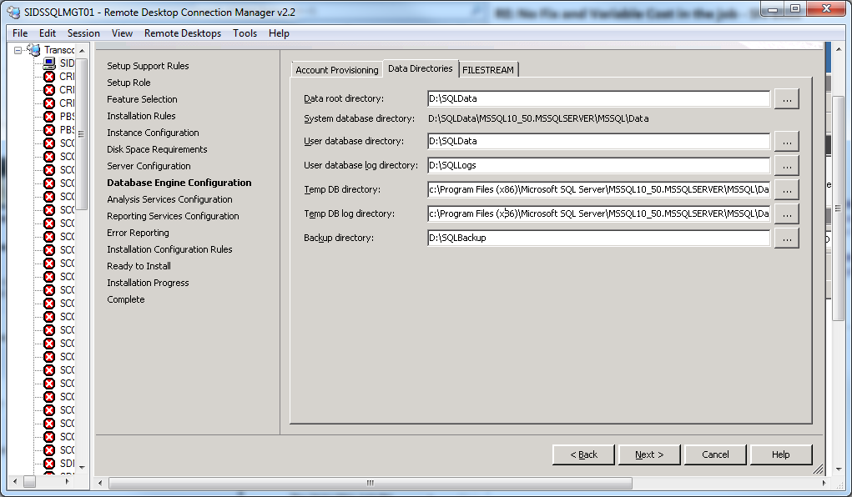

- Add your DBA group or in the case of a local development installation, the domain user, so that they may operate their own instance.
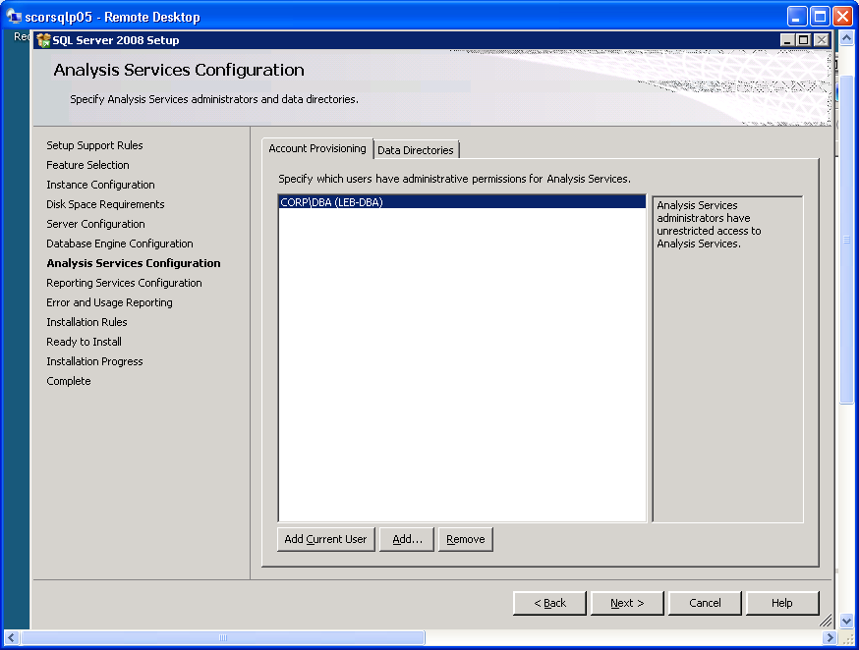

I put the data and log files at the root (d:\SQLdata, d:\SQLBackups, d:\SQLLogs), so they are easier to find, but this all depends on how you set up your drives – ideally a situation like: d:\sqldata, e:\sqllogs, f:\sqlbackups and g:\tempDB
- Choose the same Data, Log, Temp folders as for the Database Engine Configuration – unless you have a dedicated drives for the Analysis Services instance (OLAP / DW)
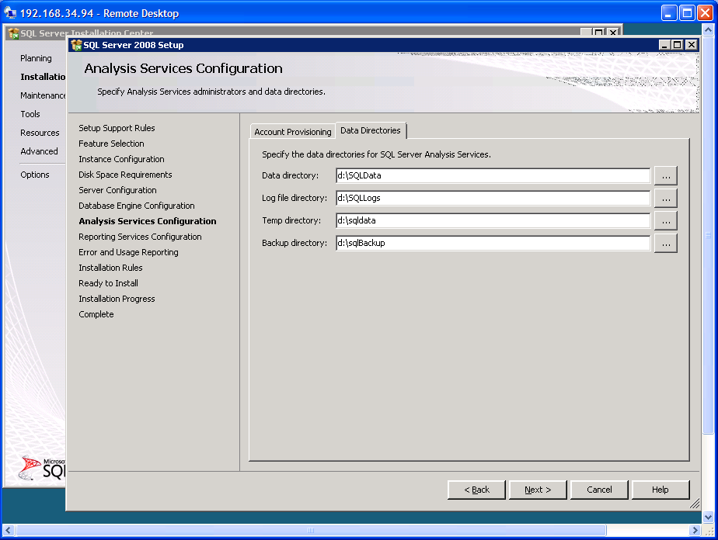Click next – and if you have installed Reporting Services, use this:
- Please read below and chose the best setup for the requirements of your server.
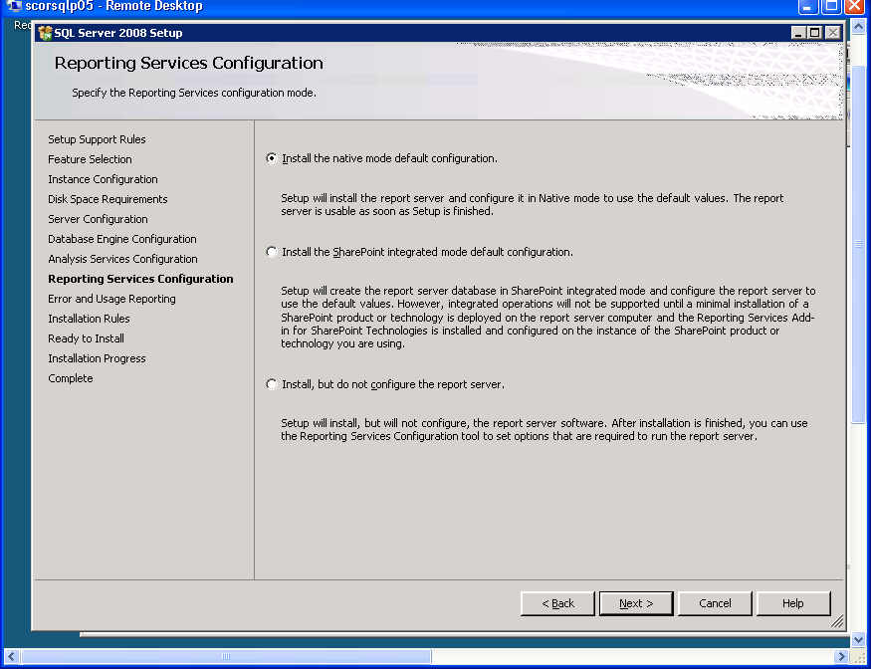
If this server is to be used for SharePoint, select the second radio button for SharePoint integration.
For more regarding SQL Server 2008 R2 and sharepoint, please read the following:
SQL Server 2008 R2 Reporting Services continues to improve integration with SharePoint. In
this release, you find better options for configuring SharePoint 2010 for use with Reporting
Services, working with scripts to automate administrative tasks, using SharePoint lists as data
sources, and integrating Reporting Services log events with the SharePoint Unified Logging
Service.
Improved Installation and Configuration
The first improvement affects the initial installation of Reporting Services in SharePoint integrated
mode. Earlier versions of Reporting Services and SharePoint require you to obtain the
Microsoft SQL Server Reporting Services Add-in for SharePoint as a separate download for
installation. Although the add-in remains available as a separate download, the prerequisite
installation options for SharePoint 2010 include the ability to download the add-in and install
it automatically with the other prerequisites.
After you have all components installed and configured on both the report server and the
SharePoint server, you need to use SharePoint 2010 Central Administration to configure the
General Application settings for Reporting Services. As part of this process, you can choose
to apply settings to all site collections or to specific sites, which is a much more streamlined
approach to enabling Reporting Services integration than was possible in earlier versions.
Another important improvement is the addition of support for alternate access mappings
with Reporting Services. Alternate access mappings allow users from multiple zones, such as
the Internet and an intranet, to access the same report items by using different URLs. You can
configure up to five different URLs to access a single Web application that provides access
to Reporting Services content, with each URL using a different authentication provider. This
functionality is important when you want to use Windows authentication for intranet users
and Forms authentication for Internet users.
16) I would select the Error Report transfer if this if the first time you are using a SQL 2008 install, so that Microsoft Support can easily help you in case of issues.
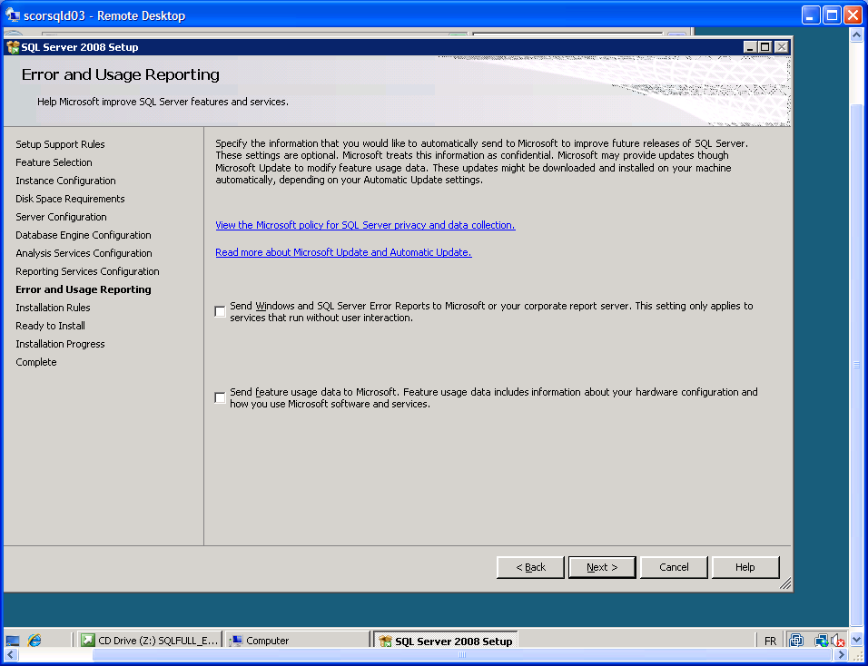
i.e. If this is a server with applications you have never worked with, check the first box (only one in R2) to help with MSFT diagnostics of problems with the server.
17) Click Next, now that all the 'Installation configuration rules' are taken care of.
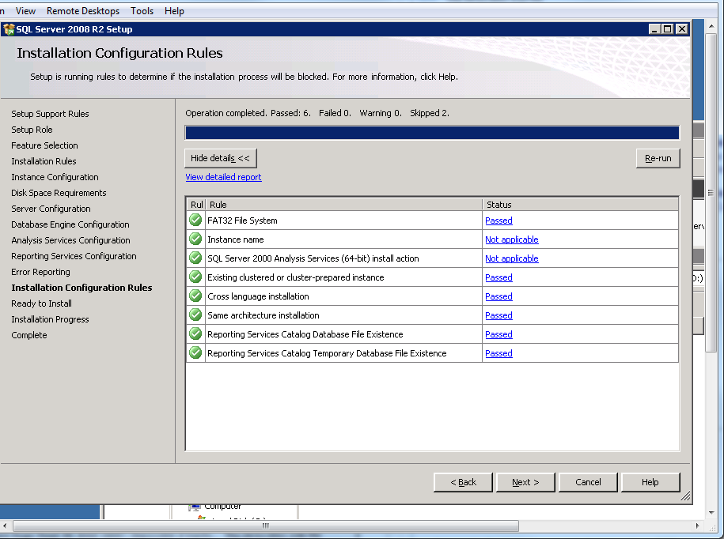

18) The following is to validate the installation (this is the point of no return ☺ ):
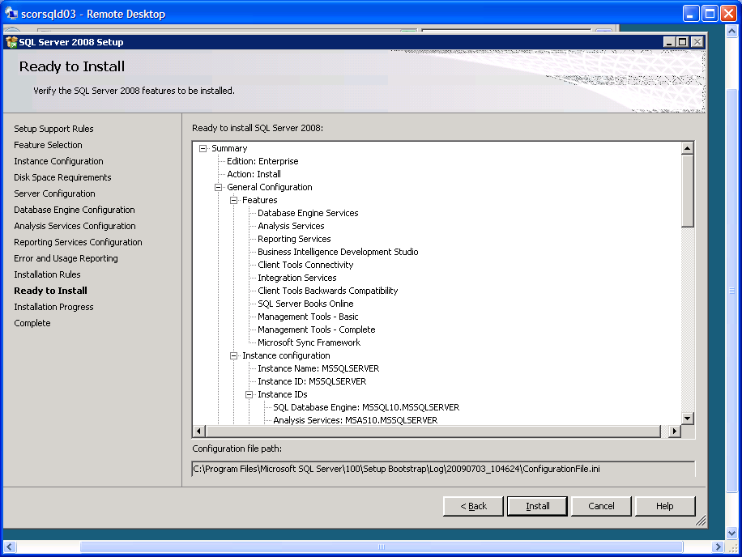
The install will take a while (20-25 minutes depending on the strength of the machine).
Be patient, this will take a long time…
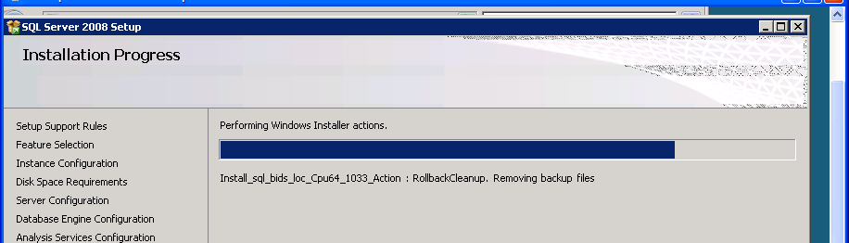

19 ) Next, and then close next page upon confirmation of successful install.

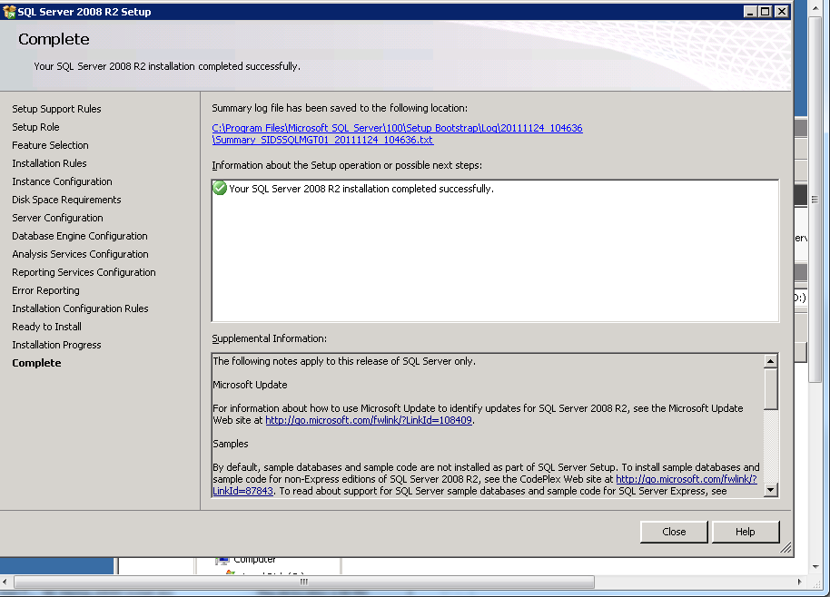
20 ) You should reboot the server once the installation is finished.
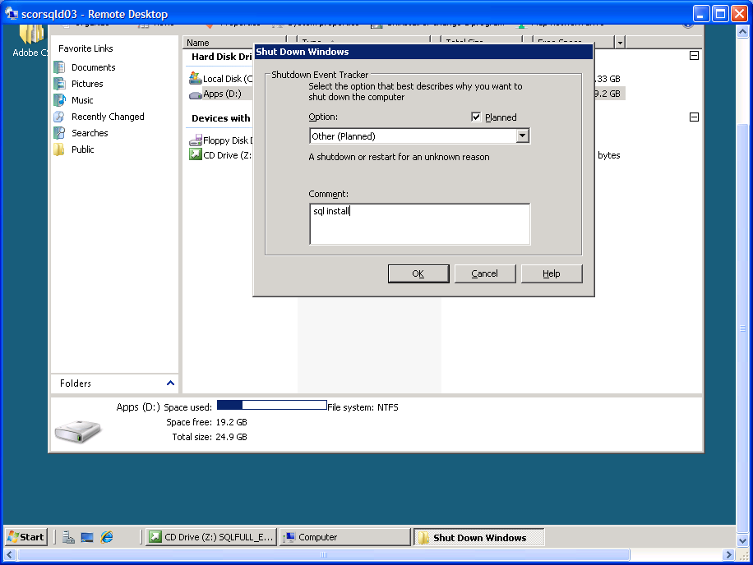 Restart the VM and then start applying Service Pack 1 – (http://blogs.msdn.com/b/sqlreleaseservices/ for the downloads)
21) Find the location of your SP1 install and double-click to begin extracting files.
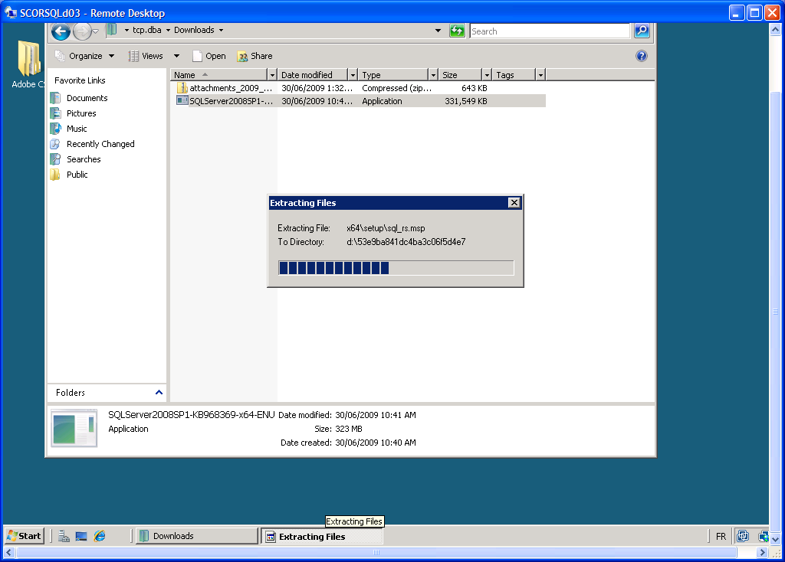

22) Make sure to have passed all the pre-install checks and click next. 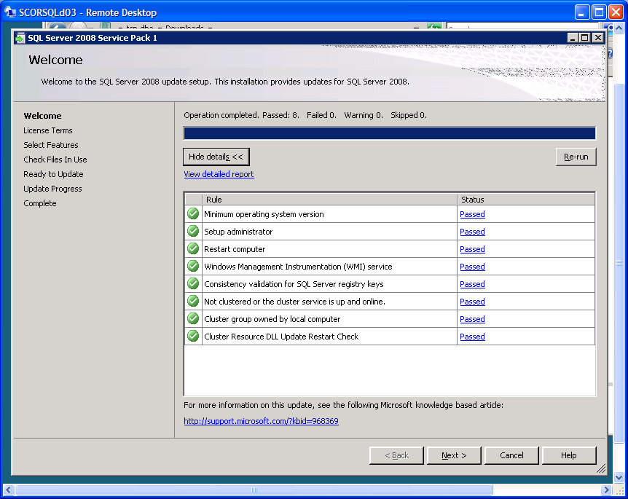
23) Click next Service pack one (should be the same more or less between SQL 2008 or R2 editions, sorry haven’t updated all the print screens, just the link for that version).
Accept the terms and click next.
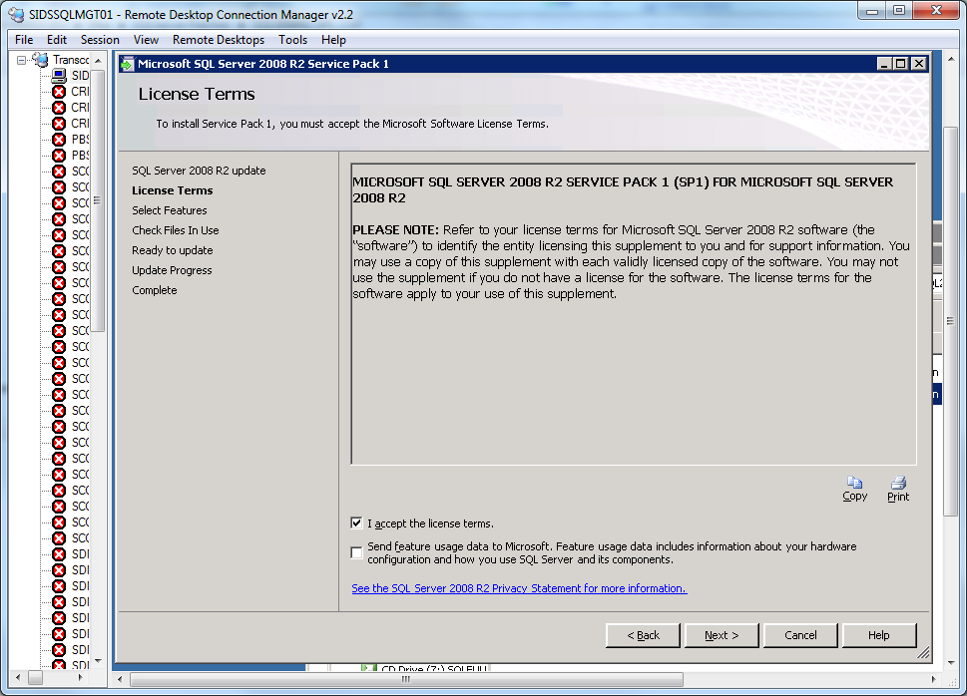

24) Leave the default instance selected, or chose the instance – beware, this will affect the shared features of ALL instances on the Server/workstation.
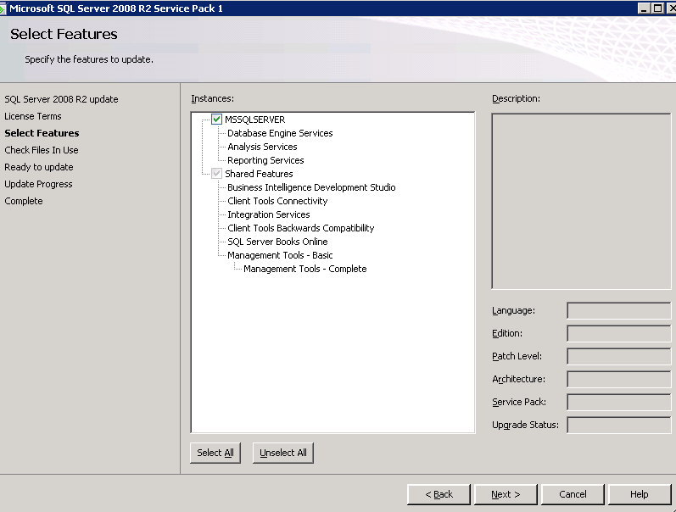

25) Click next once all files are checked and NOT open:
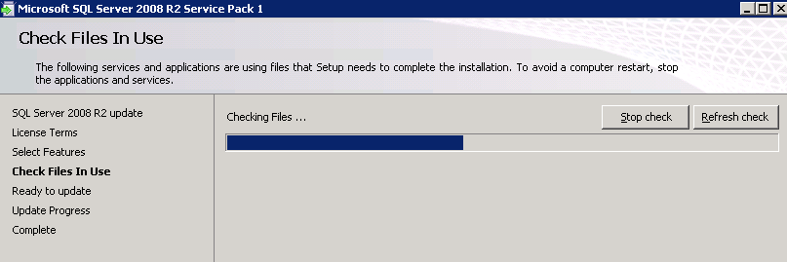

26) Validate what's going to be updated and then click Update.
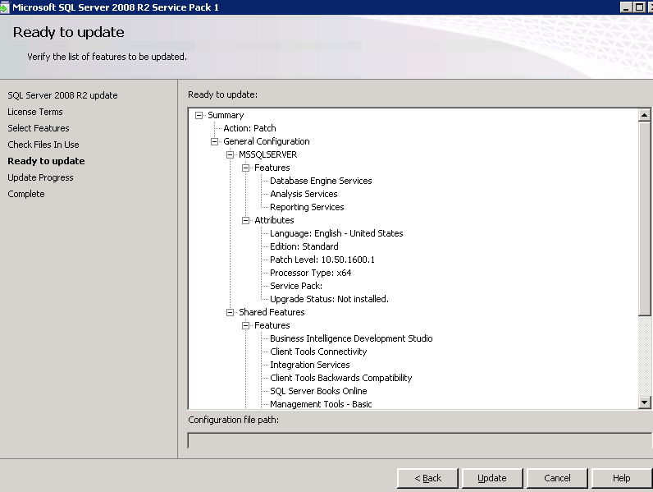

27) Click close and restart the machine.
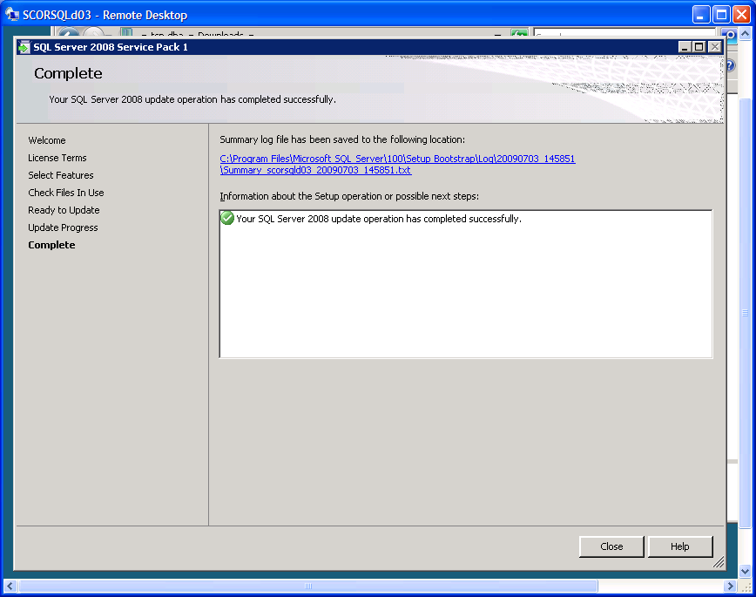

Restart the VM one more time before using it…or apply the latest Cumulative Update if there is one available. See Microsoft SQL Server Releases Blog for the latest: http://blogs.msdn.com/b/sqlreleaseservices/

28) Configure the network access:
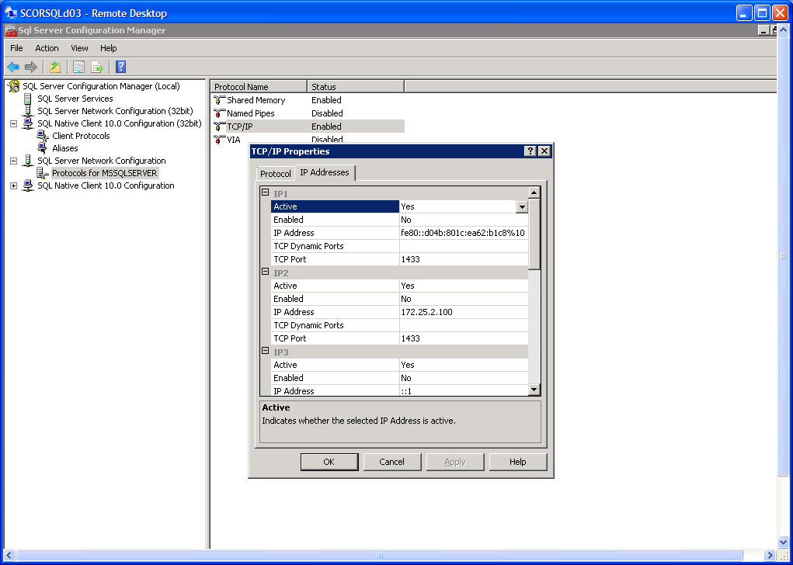
29) Enable the address in which will be used to connect.
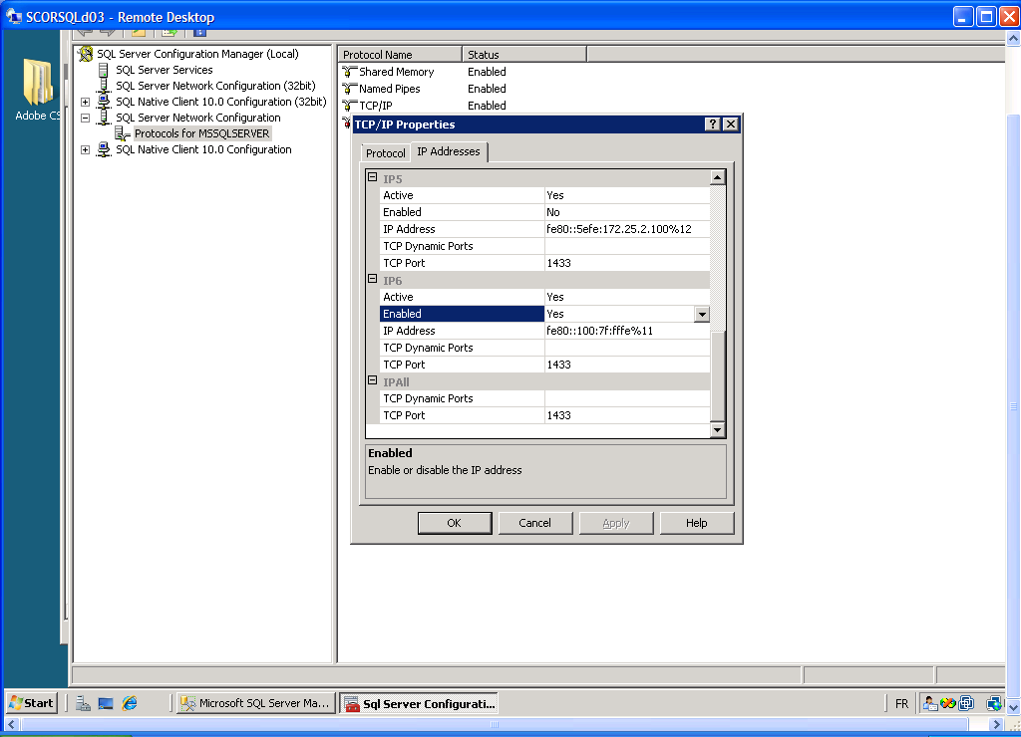
30) Enable IP6 for future proofing…restart instance each time when making security changes.

As for Database Settings, the data files and log files should be set for creation in the designated directories close to the root of the respective reserved drives (or dedicated drives, which are preferred for disk i/o splitting):
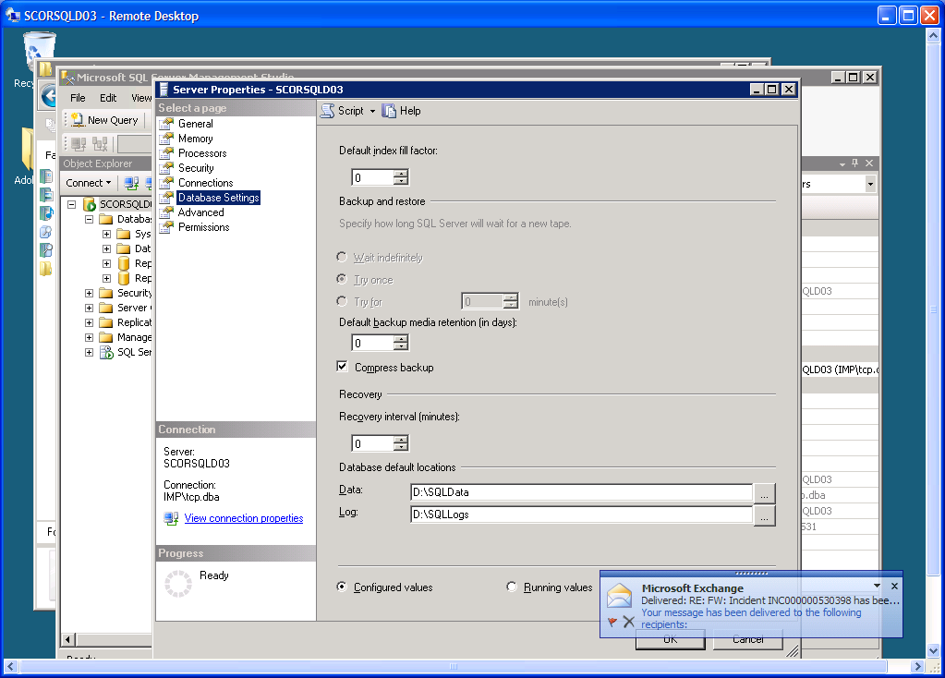
Click on Compress backup also (Enterprise Version only), this saves a boatload of space cumulatively, especially when we are using very large databases.

31) Check the Model Database - A typical Databases' configuration should be like this:
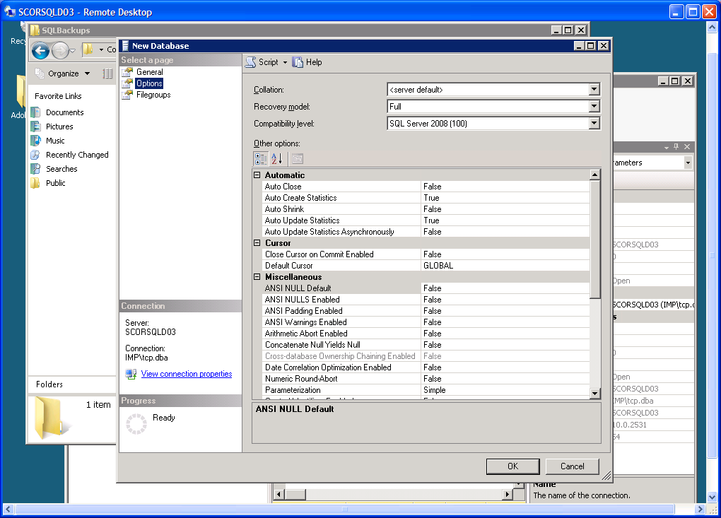
If you are not going to need point in time recovery on this instance (log files need a lot more space this way) change the default recovery model to SIMPLE.

32) On the VM server in Windows 2008, you will have to disable the windows firewall, or add an exception for the SQL ports (1433/1434).
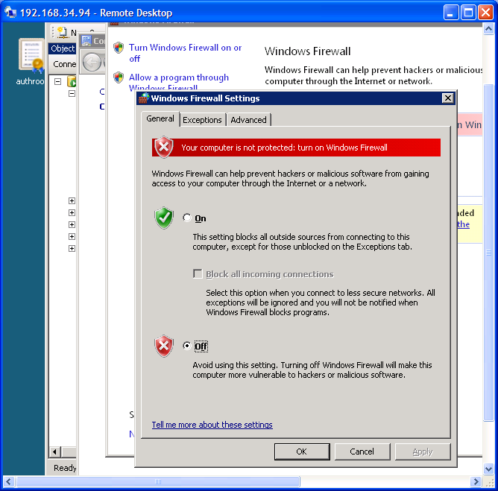
Windows Server 2008 (not R2 though – unless your memory performance is an issue!) side Optimisation for SQL Server: Enable Lock Pages in Memory on a 64-bit systems
http://sqlserverperformance.wordpress.com/2011/02/14/sql-server-and-the-lock-pages-in-memory-right-in-windows-server/
This is SQL Server MVP Glenn Berry’s great post on how to enable it. Last page should look like this.
